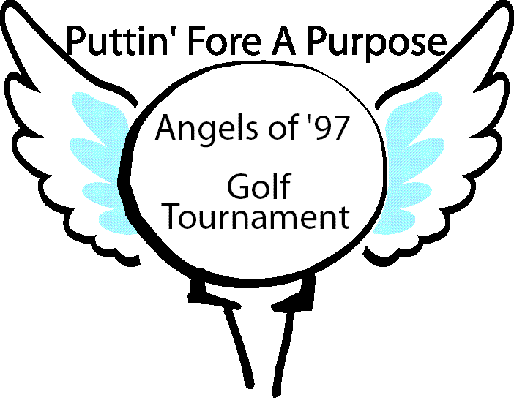
Angels of ‘97
PO Box 3511
Huntersville, NC 28070
Email: cami.meador@gmail.com
Email: mark@golfshopradio.com
Email: avissummerslewis@gmail.com

To Whom It May Concern:

I know that your company has a desire to give back to the local community and we feel we have the perfect opportunity for you to do so. The 13th Annual Angels of ’97 Putting Fore a Purpose Golf Tournament, presented by Williamson Wealth Group is being held at Pine Island Country Club in Charlotte, NC. The proceeds of the event on September 19, 2016 benefit local graduating seniors through the Angels of ’97 scholarship fund. More than 200 golfers, volunteers and spectators were in attendance last year, helping us raise in excess of $15,000. We are anxiously looking forward to this year’s event, and with your help, we believe we can reach even greater success.

Our organization is looking for help from local businesses in providing donations to the tournament in the form of sponsorships, player gift bag items, merchandise for auction/raffle items or gift cards. Your donations can help provide exposure for your business at our venue with our participants, as well as through our social media outlets. All donations are tax deductible with Angels of ’97’s 501(c)3 status. We hope you will consider donating to our organization so we can put on an outstanding event and maximize our contribution to the Angels of ’97 Scholarship Fund. Thank you for your time and consideration.

Sincerely,

Your Name
Phone
www.Angelsof97.com

PO Box 3511
Huntersville, NC 28070
Email: cami.meador@gmail.com
Email: mark@golfshopradio.com
Email: avissummerslewis@gmail.com

Website: www.Angelsof97.com

13th Annual Angels of ’97 “Puttin’ Fore A Purpose” Golf Tournament
presented by Williamson Wealth Group
Date: Monday, September 19, 2016
Time: 11:30 am-Registration Begins 12:30 pm-Shot-Gun Start
Details: Lunch/ Captain’s Choice Tournament/ Awards Dinner after Golf
Raffles/ Silent Auction / Tax Deductible Sponsorships
Location: Pine Island Country Club
1701 Stoneyridge Drive Charlotte, NC 28214
Beneficiary: Local High School Seniors receive scholarships; bereaved families receive community support.
Angels of ’97 began in 1997 to honor the lives of five students who graduated in spirit only from the North Mecklenburg Class of ’97. Angels of ’97 has grown in the past years to provide over $600,000 to local high school students to assist with higher education. The organization has expanded over the years to reach other families in our community, who have suffered the loss of a child or sibling. Additionally, Angels of ’97 has received 501(c)3 status (EIN# 56-2160394).
Below are the sponsorship opportunities available:
(ALL sponsorship logos will be hosted on our website)

Tournament Shirt Sponsor Logo on all tournament golf shirts; set up on hole (giveaway promotions for your company and/or food/beverages); Four player entries in the golf tournament and tickets to the awards dinner; commemorative hole flag; logo on all printed materials/banners during the event; promoted on social media prior to the event ($3,000-$3,500)
Trophy Sponsor Logo on all tournament trophies displayed at awards dinner; set up on hole (giveaway promotions for your company and/or food/beverages); Four tickets to awards dinner; commemorative hole flag; logo on all printed materials/banners during the event; promoted on social media prior to the event ($2,000)
Hole-in-One Sponsor Company set up on one hole (giveaway promotions for your company and/or food/beverages); Sponsor hole-in-one prize for all par 3 holes; commemorative hole flag; logo on all printed materials/banners displayed during the event; promoted on social media prior to the event ($750)
Silver Level Sponsor Company set up on one hole (giveaway promotions for your company and/or food/beverages); Four player entries in the golf tournament and tickets to the awards dinner; commemorative hole flag; logo on banner displayed during the event; promoted on social media prior to event ($650)
Beverage Sponsor Logo displayed on all beverage carts and coolers during the tournament and a tent located near driving range/putting green; promoted on social media prior to the event ($750)
Hot Dog Sponsor Company set up on one hole with hot dog vendor (giveaway promotions for your company); commemorative hole flag; logo on banner displayed during the event; promoted on social media prior to event ($500)
Goody/Swag Bag Sponsor Logo on all player goody bags (promotional item inside bag if desired); logo displayed on hole, putting green or driving range during the tournament; promoted on social media prior to the event ($400)
Bronze Level Sponsor Company set up on one hole (giveaway promotions for your company and/or food/beverages); commemorative hole flag; logo on banner displayed during the event ($300)
Hole Sponsor Logo displayed on hole, putting green or driving range during the tournament ($100)
Memory/Honor Cart Sponsor Sponsor a golf cart In Honor of a scholarship recipient or In Memory of a loved one. Your sign will be highlighted on one cart driven by tournament players ($50)

